**QUESTION**

1. **What is your ip-address?**
2. **what is your subnet mask?**
3. **What is your Network address?**
4. **What is your Broadcast address?**
5. **How many end devices can your network support?**

**Committed by :- Gaurav Bhujel**

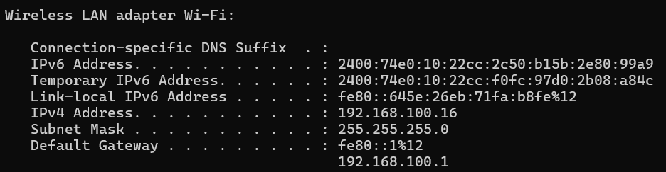

**Answers :**

1. My IP-Address is**: 192.168.100.16**
2. My Subnet Mask is**: 255.255.255.0**
3. For Network address,

IP address & Subnet mask

**192.168.100.16** & **255.255.255.0**

So , Network address is: **192.168.100.0**

1. Broadcast address is: **192.168.100.255**
2. My network can support **28 - 2 = 254** end devices.